LABORATORY WORK #3
Testing photovoltaic panels

BACKGROUND INFORAMTION

Solar energy can be part of a mixture of renewable energy sources used to meet the need for electricity. Using photovoltaic cells (also called solar cells), solar energy can be converted into electricity. Solar cells produce direct current (DC) electricity and an inverter can be used to change this to alternating current (AC) electricity. This electricity can be stored in batteries or other storage mechanisms for use at night. Batteries used for this purpose have a large storage capacity. Practical photovoltaic (PV) cells were discovered in 1954 when they were demonstrated by powering toys. In 1958 they found wide acceptance as part of the space program after initial success on the Vanguard I satellite. PVs are made from silicon and other semiconductor materials. Silicon crystals have all four valence electrons bound with other silicon valence electrons. When silicon is “doped” with atoms of with fewer valence electrons is brought in contact with silicon doped with atoms with extra valence electrons, an electric field is created the electrons from atoms with extra valence electrons fill “holes” created by atoms with fewer electron. When sunlight enters a PV panel, the light can separate an electron from an atom and the electric field helps move the electrons to charge collecting areas. The electrons are then gathered on the surface of the solar cell by a grid of metal connected to a circuit. The circuit allows the electrons to flow to the electron-poor back of the cell from the electron-rich front of the cell. Photovoltaic panels are oriented to maximize the use of the sun’s light, and the system angles can be changed for winter and summer. When a panel is perpendicular to the sunlight, it intercepts the most energy. Students are familiar with the PV panels used in most calculators.

MATERIALS

Obtain a materials kit from your teacher. Check that it contains the following
materials:
• small PV panels
• two electrical leads with alligator clips
• DC ammeter
• DC volt meter
• source of bright light or access to direct sunlight (desk lamp or flashlight
could be substituted)
• protractor

Assemble circuit on the figure bellow.
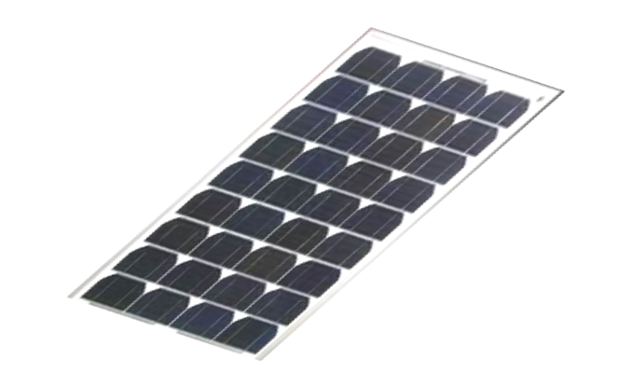
А
V
̶
+
-

1. With just 1 PV panel in the circuit, shade 1/4 of the PV panel with a piece of cardboard or paper and take a reading. Shade 1/2, 3/4 and then all of the photovoltaic cell. Record the readings in Data Table 1. Construct IV-characteristics on one graph for each situation.
Table 1. Effect of Shading on Cell Current

Amount of Shade Current

 | ¼ covered |  | ½ covered |  | ¾ covered |  | All covered
Number of experiment, № | U, V | I, mA | U, V | I, mA | U, V | I, mA | U, V | I, mA
1
2
3
4
5
6
7
8
9
10
11
12
13
14
15

2. Place the PV panel(s) directly pointed at the sun (or light source). Using a protractor to determine the angle, slant the PV panel(s) at 15-degree intervals away from the direct perpendicular position. Record the amps generated at every 15-degree change in Data Table 2. Construct IV-characteristics on one graph for each situation.
Table 2. Effect of Tilt Angle on Cell Current

Angle Current
 | 15⁰ |  | 30⁰ |  | 45⁰ |  | 60⁰
Number of experiment, № | U, V | I, mA | U, V | I, mA | U, V | I, mA | U, V | I, mA
1
2
3
4
5
6
7
8
9
10
11
12
13
14
15

Make a conclusion on obtained data.

